**“TRAFFIC FLOW AND OPTIMIZATION”**

**Om Yadav, Isha Nar, Ubaid Karbhari, Nikhil Thorat, Dr. Chandrashekhar Goswami**

**Abstract:**

This project report explores the mechanics of traffic flow and strategies for its optimization. Traffic congestion is a prevalent issue in urban areas, leading to inefficiency, pollution, and increased travel times. To address this problem, this study investigates various traffic flow models and optimization strategies. We collected and examined real-world traffic data, applied traffic flow models, and assessed the impact of optimization strategies. Our findings reveal that traffic flow can be significantly improved through the implementation of intelligent transportation systems, signal timing adjustments, and other optimization measures. This report provides valuable revelation and counsels for policymakers and transportation authorities to enhance traffic flow, reduce congestion, and create more efficient and sustainable urban transportation systems.

**1.Introduction:**

Traffic congestion is a ubiquitous and persistent issue in urban areas worldwide, causing a myriad of problems ranging from wasted time and fuel to increased greenhouse gas emissions and decreased quality of life. The steady increase in the number of vehicles on our roads, coupled with limited infrastructure development, makes addressing traffic flow and optimization an imperative for urban planners, policymakers, and transportation engineers. This project report delves into the multifaceted realm of traffic flow and optimization, seeking to offer solutions to the challenges posed by urban traffic congestion.

**2.Literature Review:**

The literature review below provides an overview of existing research and developments in the field of Traffic Flow and Optimization, covering various methodologies, technologies, and applications.

1. **Fundamental Understanding of Traffic Flow:**

Lighthill-Whitham-Richards (LWR) Model: The LWR model is widely used for understanding the fundamental characteristics of traffic flow. It describes traffic flow using partial differential equations based on the conservation of vehicles. Greenshields Model: Introduced in the 1930s, the Greenshields model characterizes traffic flow as a function of traffic density and speed. It forms the basis for many traffic flow studies and optimization strategies.

1. **Fundamental Concepts of Traffic**

**Flow:**

Lighthill-Whitham-Richards (LWR) Model: Introduced in 1955, this macroscopic traffic flow model describes the propagation of traffic density waves along a roadway.

Cell Transmission Model (CTM): Developed as an extension of the LWR model, CTM represents traffic flow as a series of cells and governs the movement of vehicles between these cells based on density and speed.

Kinematic Wave Theory: Proposes that traffic flow behaves like a wave, with density and speed varying continuously along the roadway.

1. **Traffic Flow Characteristics and Parameters:**

Traffic Density, Flow, and Speed: These parameters form the basis for analyzing traffic conditions and performance. Traffic Congestion and Bottlenecks: Understanding the causes and effects of congestion is crucial for designing effective traffic management strategies. Flow-Density Relationships: Empirical relationships such as the fundamental diagram depict the nonlinear relationship between traffic flow, density, and speed.

1. **Traffic Control and Optimization**

**Strategies:**

Traffic Signal Control: Optimization algorithms such as genetic algorithms, reinforcement learning, and neural networks are applied to optimize signal timings and coordination. Dynamic Traffic Assignment (DTA): Allocates traffic flows dynamically to minimize travel time and congestion across a transportation network. Intelligent Transportation Systems (ITS): Integration of advanced technologies like real-time traffic monitoring, adaptive signal control, and vehicle-to-infrastructure communication for efficient traffic management.

1. **Emerging Technologies and Future Directions:** Connected and Autonomous Vehicles (CAVs): The integration of CAVs promises to revolutionize traffic flow management through improved coordination, platooning, and enhanced safety. Big Data Analytics: Leveraging large-scale traffic data to derive insights, predict traffic patterns, and develop proactive optimization strategies. MultiModal Transportation Optimization: Integrating various modes of transportation, including public transit, cycling, and walking, to create seamless and efficient urban mobility solutions.
2. Mr. Udit Batra and Mr. Mandar V. Sarode

(2013) supervised and inspected the traffic blueprints on Sadar Main Road (Anjuman College Square and Liberty

Square) and WHC Road (Law College Square and Shankar Nagar Square) for the target of an source and end point study. The researchers used a blend of tallying manually and cinematography approach for data accumulation of traffic. The true capacity of opted route was measured during the heavy traffic hour. The authors inferred from their observation that public transportation needed to be reinforced and due to presence of school and residential houses, increased traffic was noted during school hours. Two wheeler vehicle was the favored mode.

1. S. R. Samal, P. Gireesh Kumar, J. Cyril

Santhosh, and M. Santhakumar’s (2002) detected their selected expands and probed the received data regarding travel time index, buffer time index, planning time index and also detected road capability while referring IRC 106. Their study marked influence on economy, health and environment and respective mitigation tactics were recommended on the same. Enacting stringent regulations , governing road side activities and offering sufficient parking space was advised.

1. Nuzhat Nueery Haque, Sanchari Halder, et. al. (August 2013) reviewed service flow rate, spatial distribution, vehicle configuration, changes in flow rate, and uninterrupted flow and gave recommendations and boundaries in line with their observations. In addition to this, they suggested conducting a velocity study on city roadway connections for anticipated projects.

**3. Block Diagrams:**

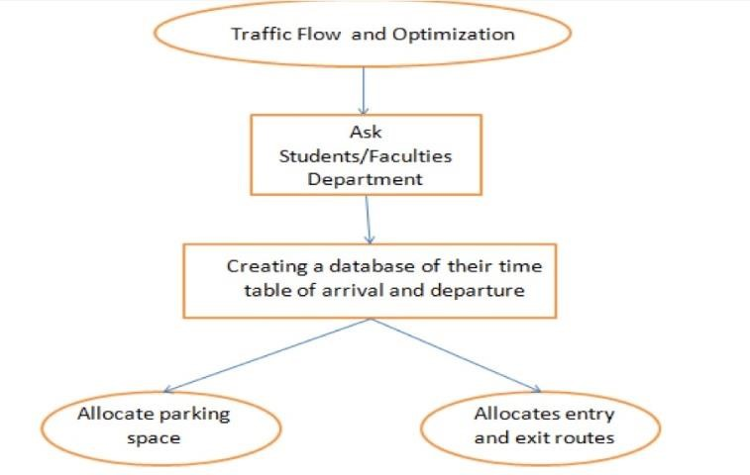

**System Architecture:**

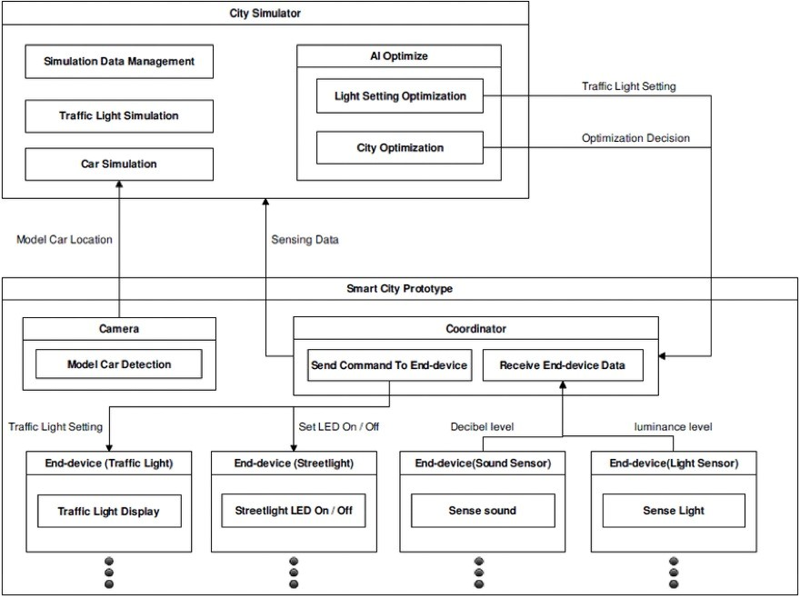

**4.Methodology:**

The methodology adopted for this project is structured and holistic, involving data collection, analysis, traffic flow modeling, optimization strategy evaluation, case studies, and recommendation formulation. Data will be gathered from diverse sources and analyzed using statistical methods and data visualization. Both macroscopic and microscopic traffic flow models will be applied to simulate scenarios. Various optimization strategies will be evaluated for their impact on traffic flow. Real-world case studies will provide practical insights. An iterative process will guide adjustments and refinements throughout the project, ensuring the flexibility to address evolving insights and challenges. This comprehensive approach aims to deliver actionable recommendations for enhancing urban transportation systems.

Methodology for Traffic Flow and

Optimization:

**1. Data Collection:**

* Collecting data on traffic volume, speed, density, and other relevant parameters using

various sources such as traffic sensors, cameras, GPS devices, and mobile apps.

* Utilizing historical traffic data to understand traffic patterns, identify bottlenecks, and calibrate traffic flow models.

**2. Traffic Flow Modeling:**

* Selecting appropriate traffic flow models based on the scale of analysis (microscopic, mesoscopic, or macroscopic) and the level of detail required.
* Implementing traffic flow models using software tools such as VISSIM, AIMSUN, SUMO, or custom simulation platforms.
* Validating the accuracy of the traffic flow model by comparing simulated results with observed data and established benchmarks.

**3. Optimization Problem Formulation:**

* Defining the optimization objectives, which could include minimizing travel time, reducing congestion, maximizing throughput, or improving overall system efficiency.
* Identifying decision variables such as signal timings, lane configurations, route choices, or vehicle dispatching strategies.
* Formulating mathematical optimization models, considering constraints such as capacity limitations, safety requirements, and regulatory policies.

**4. Optimization Techniques:**

* Applying optimization algorithms such as genetic algorithms, simulated annealing, ant colony optimization, or particle swarm optimization to solve the formulated optimization problems.
* Incorporating advanced optimization techniques like reinforcement learning, deep learning, or machine learning to adaptively optimize traffic control strategies based on realtime data and feedback.

Considering multi-objective optimization approaches to balance conflicting objectives and find Pareto-optimal solutions that offer trade-offs between competing criteria.

**5. Implementation and Evaluation:**

* Implementing optimized traffic control strategies in real-world traffic management systems, traffic signal controllers, or intelligent transportation systems (ITS).
* Deploying connected vehicle technologies and infrastructure upgrades to support optimized traffic flow solutions.
* Evaluating the effectiveness of optimization strategies through field trials, simulation experiments, or controlled studies, measuring performance metrics such as travel time savings, congestion reduction, fuel consumption, and environmental impacts.
* Iteratively refining optimization algorithms and strategies based on evaluation results and feedback from stakeholders, including transportation agencies, city planners, and the general public.

**6. Integration with Urban Planning:**

* Integrating traffic flow optimization efforts with broader urban planning initiatives, considering factors such as land use, zoning regulations, public transit accessibility, and sustainable development goals.
* Collaborating with urban planners, architects, environmentalists, and policymakers to design holistic transportation solutions that prioritize multimodal mobility, pedestrian safety, and community livability.
* Engaging stakeholders through participatory planning processes, public consultations, and collaborative decision-making frameworks to ensure that traffic flow optimization efforts align with the needs and aspirations of the community.

By following a systematic methodology encompassing data collection, traffic flow modeling, optimization problem formulation, application of optimization techniques, implementation, evaluation, and integration with urban planning, researchers and practitioners can develop effective strategies for optimizing traffic flow and improving urban mobility.

**5.Results:**

When discussing the results of traffic flow and optimization research, it's important to consider findings from various studies and implementations. Here are some key results and outcomes observed in this field:

**1. Optimized Traffic Signal Control:**

* Implementation of advanced optimization algorithms for traffic signal control has shown significant improvements in reducing congestion and travel time.
* Studies have demonstrated that adaptive signal control systems, which adjust signal timings in real-time based on traffic conditions, can lead to notable reductions in delays and queue lengths at intersections.

**2. Dynamic Traffic Assignment (DTA):**

* DTA approaches have been successful in dynamically allocating traffic flows across transportation networks to minimize overall travel time and congestion.
* Results indicate that DTA strategies, when integrated with real-time traffic information and feedback mechanisms, can effectively redistribute traffic and alleviate congestion hotspots.

**3. Intelligent Transportation Systems (ITS):**

* Deployment of ITS technologies, such as realtime traffic monitoring systems and variable message signs, has shown positive impacts on

traffic management and traveler information dissemination.

* Studies have highlighted the effectiveness of ITS in improving safety, reducing incident response times, and enhancing overall transportation efficiency.

**4. Connected and Autonomous Vehicles (CAVs):**

* Research on CAVs has demonstrated the potential to significantly improve traffic flow through features such as cooperative adaptive cruise control and platooning.
* Simulation studies have shown that CAVs can enhance traffic stability, increase throughput on roadways, and reduce fuel consumption and emissions through smoother driving patterns.

**5. Big Data Analytics:**

* Analysis of large-scale traffic data has yielded valuable insights into traffic patterns, bottlenecks, and congestion dynamics.
* Results from data-driven approaches have enabled the development of predictive models for traffic flow, facilitating proactive management and optimization strategies.

**6. Multi-Modal Transportation Optimization:**

* Integration of multiple transportation modes, including public transit, cycling, and walking, has shown promise in reducing reliance on singleoccupancy vehicles and alleviating congestion.
* Studies have indicated that well-designed multimodal transportation networks can enhance accessibility, promote sustainable travel behavior, and improve overall urban mobility.

**7. Sustainability and Environmental Impacts:**

* Optimization strategies aimed at reducing traffic congestion and improving traffic flow have the potential to mitigate environmental impacts such as air pollution and greenhouse gas emissions.
* Results from studies assessing the environmental benefits of traffic optimization highlight the importance of considering sustainability goals in transportation planning and decision-making.

Overall, the results of traffic flow and optimization research underscore the significance of adopting integrated, data-driven approaches and leveraging advanced technologies to address the complex challenges of urban mobility and create more efficient, sustainable transportation systems.

**6. Discussion:**

**1. Challenges in Traffic Flow Management:**

* Urbanization: Rapid urbanization leads to increased demand for transportation, exacerbating traffic congestion and flow disruptions.
* Limited Infrastructure: Infrastructure limitations pose challenges in accommodating growing traffic volumes, especially in densely populated urban areas.
* Heterogeneous Traffic: Variability in vehicle types, sizes, and driving behaviors complicates traffic flow modeling and optimization efforts.

**2. Optimization Strategies:**

* Dynamic Traffic Signal Control: Adaptive signal control systems dynamically adjust signal timings based on real-time traffic conditions, improving traffic flow efficiency.
* Route Optimization: Utilizing advanced algorithms to optimize route assignment and guide drivers towards less congested paths, reducing overall travel time and congestion.
* Multi-Modal Integration: Integrating various transportation modes and promoting alternatives such as public transit, cycling, and walking to alleviate road congestion.
* Smart Parking Management: Implementing smart parking systems to efficiently manage parking spaces and reduce traffic congestion caused by drivers searching for parking.

**3. Role of Technology:**

* Connected Vehicle Technologies: Vehicle-tovehicle (V2V) and vehicle-to-infrastructure (V2I) communication enable proactive traffic management, such as cooperative adaptive cruise control and platooning, enhancing traffic flow and safety.
* Big Data Analytics: Harnessing large-scale traffic data enables predictive modeling, real-time monitoring, and data-driven decision-making to optimize traffic flow and infrastructure utilization.
* Artificial Intelligence (AI) and Machine Learning: AI-driven algorithms learn from historical traffic data to predict traffic patterns, optimize signal timings, and develop adaptive traffic control strategies, improving overall traffic flow efficiency.

**4.Sustainability and Environmental**

**Considerations:**

* Emission Reduction: Optimizing traffic flow reduces idling time and stop-and-go traffic, leading to lower fuel consumption and greenhouse gas emissions, contributing to environmental sustainability.
* Encouraging Sustainable Transportation Modes: Promoting sustainable transportation modes such as cycling, walking, and public transit reduces reliance on private vehicles and alleviates traffic congestion while reducing environmental impact.

**5. Policy Implications:**

* Integrated Transportation Planning: Collaborative efforts between transportation agencies, urban planners, policymakers, and stakeholders are essential for developing comprehensive transportation plans that prioritize traffic flow optimization and sustainable mobility.
* Investment in Infrastructure: Strategic investments in transportation infrastructure upgrades, such as road expansion, intersection improvements, and public transit enhancements, are crucial for enhancing traffic flow capacity and efficiency.

**6. Future Directions:**

* Autonomous Vehicles: The widespread adoption of autonomous vehicles has the potential to revolutionize traffic flow management by improving traffic flow coordination, reducing accidents, and optimizing road capacity utilization.
* Mobility as a Service (MaaS): MaaS platforms offer integrated, on-demand transportation services, providing seamless mobility solutions that prioritize efficiency, convenience, and sustainability.
* Shared Mobility: Shared mobility services, including ride-sharing and micro-mobility options, play a significant role in reducing singleoccupancy vehicle trips, mitigating traffic congestion, and promoting sustainable urban mobility.

In conclusion, addressing the challenges of traffic flow and optimization requires a multi-faceted approach that integrates technological advancements, data-driven solutions, policy interventions, and sustainable transportation initiatives. By leveraging innovative strategies and collaborative efforts, it is possible to create more efficient, resilient, and sustainable transportation systems that meet the evolving mobility needs of urban populations.

**7. Conclusion**

In conclusion, this project delved into the intricate world of traffic flow and optimization within urban environments. The global rise in urbanization and the increasing number of vehicles on our roads underscore the pressing need to address traffic congestion. Through a systematic and data driven methodology, we collected, analysed, and modeled real-world traffic data, providing valuable insights into current traffic conditions and patterns. Our evaluation of various traffic optimization strategies, including adaptive signal control and lane management, emphasized the potential for improving traffic flow and reducing congestion. Real-world case studies provided practical examples of successful implementations, showcasing the transformative effects of well planned strategies. The recommendations formulated in this report aim to guide policymakers, urban planners, and transportation authorities toward creating more efficient, sustainable, and equitable urban transportation systems. As our cities continue to grow and evolve, the findings and insights from this project serve as a foundation for future research and policy decisions, with the ultimate goal of making urban mobility smoother, environmentally responsible, and conducive to a higher quality of life for all residents.

**8. Reference:**

1. "Traffic Flow Fundamentals" by Traffic Flow Theory Committee, Transportation Research Board
2. "Traffic Engineering" by Roger P. Roess, Elena S. Prassas, and William R. McShane
3. "Principles of Transportation Engineering" by Partha Chakroborty, Animesh Das, and L.R. Kadiyali.
4. Daganzo, C. F. (1995). "The cell transmission model: A dynamic representation of highway traffic consistent with the hydrodynamic theory." Transportation Research Part B: Methodological, 29(4), 269287.
5. van Arem, B., van Driel, C. J., & Visser, R. (2006). "The impact of cooperative adaptive cruise control on traffic-flow characteristics."
6. IEEE Transactions on Intelligent
7. Transportation Systems, 7(4), 429-436.
8. Wang, Y., Yin, H., Tang, W., & Li, Y. (2019). "Recent advances in traffic flow theories and models: A review." Transportation Research Part B: Methodological, 127, 134-157.
9. Mahmassani, H. S., & Jayakrishnan, R. (1990). "Traffic management using dynamic traffic assignment: algorithm and experimentation." In Proceedings of the IEEE, 78(10), 1665-1673.
10. Hoogendoorn, S. P., & Bovy, P. H. (2001). "State-of-the-art of vehicular traffic flow modelling." Proceedings of the Institution of Mechanical Engineers, Part I: Journal of Systems and Control Engineering, 215(4), 283303.
11. Newell, G. F. (2002). "A simplified carfollowing theory: A lower order model." Transportation Research Part B:
12. Methodological, 36(3), 195-205.
13. Smith, M. J. (1981). "The Maximum Capacity of Uninterrupted Traffic Flow Through an Area." Transportation Science, 15(1), 16-35.
14. Khoshyaran, M. A. (2019). "Optimization and control of traffic flow on urban road networks using deep reinforcement learning."
15. (Doctoral dissertation, Queensland University of Technology).
16. Wong, J. Y. (2018). "Dynamic traffic management and control strategies for mixed autonomous and human-driven vehicles." (Master's thesis, University of California, Berkeley).

17] Transportation Research Board (TRB): <https://www.trb.org/>

18] Chat GPT

19] Institute of Transportation Engineers (ITE):

https://www.ite.org/

These references cover a wide range of topics related to traffic flow and optimization, including theoretical foundations, modeling techniques, optimization algorithms, and practical applications. Depending on your specific area of interest and focus, you may find these resources helpful for further exploration and research.